CLOUDFRONT & ROUTE 53

- Configure VPC peering in cross regions.

Objective : The objective of this task is to establish private network connectivity between two VPCs located in different AWS Regions, allowing resources such as EC2 instances to communicate with each other using private IP addresses

Prerequisites :

  - • Two VPCs in different AWS Regions.
  - • VPC CIDR blocks must not overlap.
  - • Access to both AWS Regions.
  - • Route tables for the subnets that need communication.
  - • Security Groups/NACLs must allow the required traffic.

Step-by-step implementation :
Step 1 : Create VPCs
Mumbai:
VPC-A
CIDR: 10.0.0.0/16
Subnet: 10.0.1.0/24
Singapore:
VPC-B
CIDR: 20.0.0.0/16
Subnet: 20.0.1.0/24
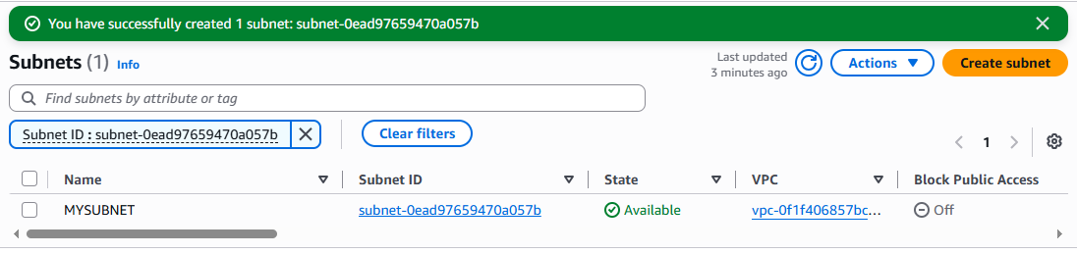
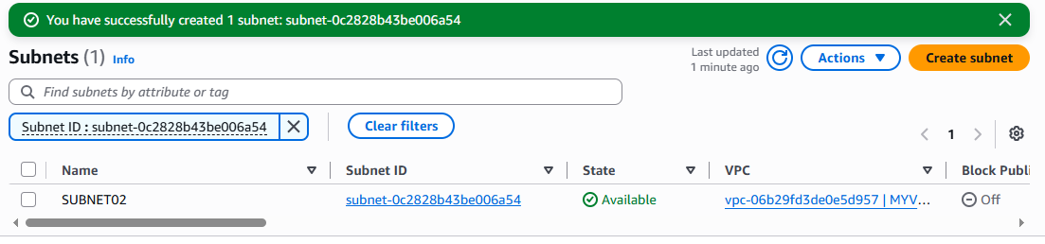
Step 2 : Create VPC Peering Connection
Go to: AWS Console → VPC → Peering connections → Create peering connection
Configure:
Name: Mumbai-Singapore-Peering
Requester VPC:
VPC-A (Mumbai)
Accepter VPC:
VPC-B (Singapore)
Region:
Another Region
Accepter Region:
Asia Pacific (Singapore)
Click Create peering connection.

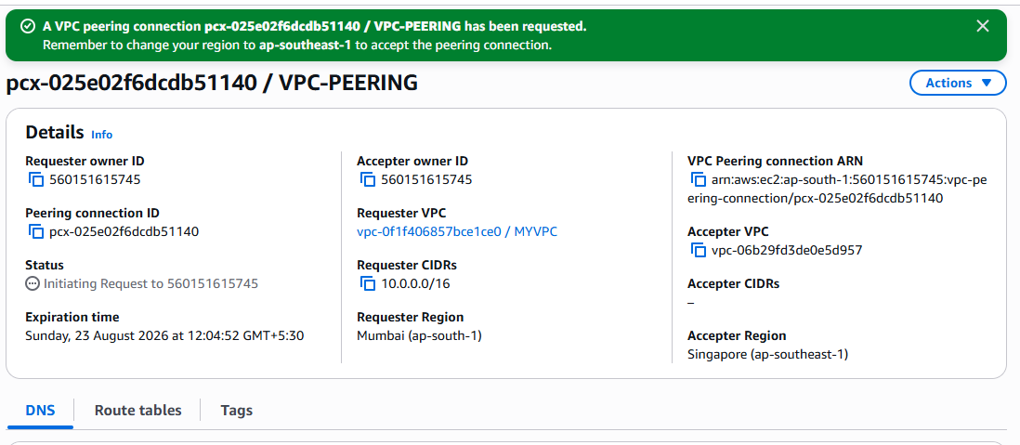

Step 3 : Accept the peering request
Switch to Singapore (ap-southeast-1).
Go to:
VPC → Peering connections
Select the pending peering connection → Actions → Accept request
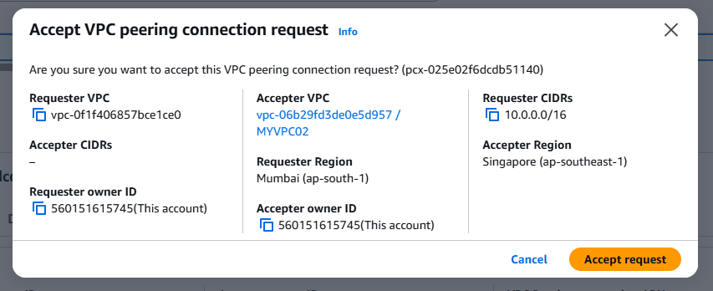
Step 4 : Update Mumbai route table
Mumbai VPC needs a route to Singapore:
Destination: 20.0.0.0/16
Target: pcx-xxxxxxxx

Step 5 : Update Singapore route table
Singapore VPC needs a route back to Mumbai:
Destination: 10.0.0.0/16
Target: pcx-xxxxxxxx
Step 6 : Configure Security Groups
Singapore EC2 Security Group :
Type: SSH
Port: 22
Source: 10.0.0.0/16
Step 7 : Test connectivity
From an EC2 instance in Mumbai:
ping <Singapore-private-IP>

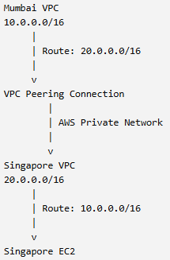

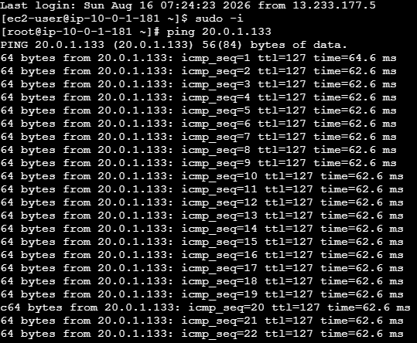
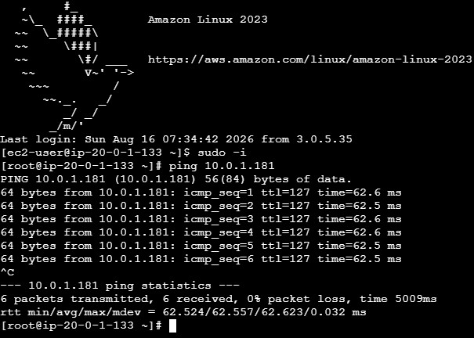

2 Purchase one domain from GoDaddy.

Objective :
Purchase and register a domain name using Hostinger.

Prerequisites:
  - • Hostinger account
  - • Valid email/mobile number
  - • Valid payment method
  - • Desired domain name
  - • Internet connection

Purchased Domain in https://hpanel.hostinger.com/domains
Domain name : stathum.sbs

Step-by-step Implementation :

Step 1: Open Hostinger
Goto : https://www.hostinger.com/in/
Step 2: Open Domain Search
Go to Hostinger Domain Search and search: stathum
Step 3: Add the domain
  - • Click Add to cart
  - • Select the registration period
  - • Review the price
  - • Continue to checkout
Step 4: Create/Login to Hostinger account
Enter your:
- Email address :
- Password :
- Required account information :
Step 5: Enter domain registration details
Provide the required contact information. Domain privacy is included free where supported.

Step 6: Make payment
Choose an available payment method and complete the payment.

Step 7: Verify the domain
After successful registration, open hPanel → Domains.
you should see:
Domain: dewax.in
Status: Active
Domain name : stathum.sbs

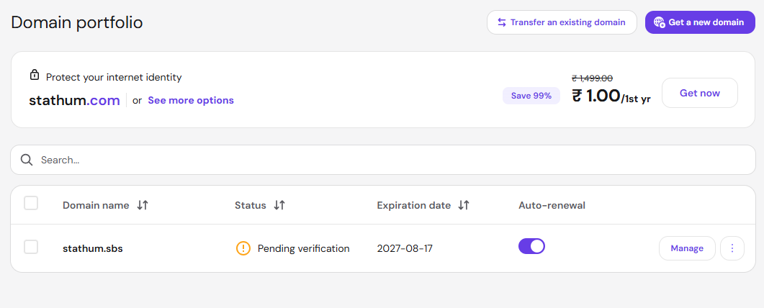

- Deploy static website in S3.

Objective
To host a static website using an Amazon S3 bucket and make it accessible through a web browser.

Prerequisites
  - AWS account
  - IAM user/role with S3 permissions
  - AWS CLI configured, if using CLI
  - An S3 bucket
  - Basic HTML file such as index.html
Step by step implementation :

Step 1: Create an S3 Bucket
- Open the AWS Management Console.
- Search for S3.
- Click Create bucket.
- Enter a globally unique bucket name
- Select your desired AWS Region, for example:
Asia Pacific (Mumbai) ap-south-1
- Keep Object Ownership as:
  - ACLs disabled
  - Bucket owner enforced
- For this traditional S3 website-hosting lab, you will need to allow public access to the website objects, so understand the security implications before disabling the Block Public Access protections.
- Click Create bucket.
Step 2: Create index.html
Create index.html
<!DOCTYPE html>
<html>
<head>
<title>My S3 Website</title>
</head>
<body>
<h1>Welcome to My Website</h1>
<p>This website is hosted using Amazon S3.</p>
</body>
</html>

Step 3: Upload the HTML File
Go to:
S3 → Your bucket → Upload → Add files
Select:
Index.html
Click to Upload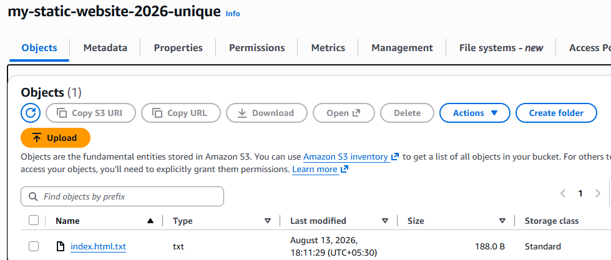

Step 4: Enable Static Website Hosting
Open your bucket and go to:
Properties → Static website hosting
Click Edit.
Select:
Enable
Choose:
Hosting type:
Host a static website
Enter :
Index document:
index.html
save changes

Step 5: Allow Public Read Access

For the traditional S3 website endpoint to serve content publicly, the website objects need appropriate public-read permissions.
Go to:
Permissions → Block public access
Edit the settings as appropriate for your lab and acknowledge the warning.
Then add a bucket policy.
{
"Version": "2012-10-17",
"Statement": [
{
"Sid": "PublicReadGetObject",
"Effect": "Allow",
"Principal": "*",
"Action": "s3:GetObject",
"Resource": "arn:aws:s3:::dewax-static-website-2026/*"
}
]
}
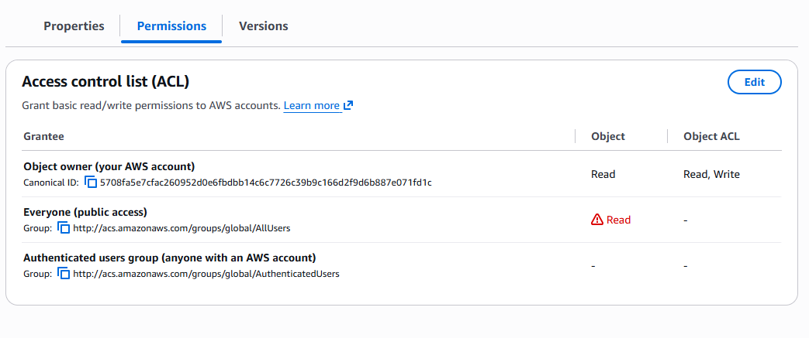
Step 6: Get the Website URL
Go back to:
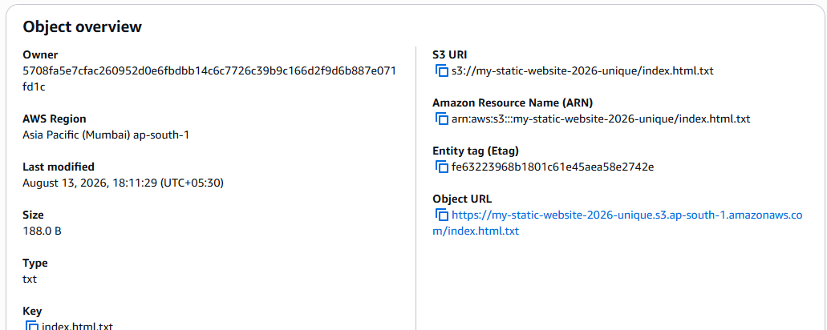
S3 → Bucket → Properties → Static website hosting
You will see a Bucket website endpoint.

Step 7: Test the Website
Modify your index.html, upload it again, and refresh the website.
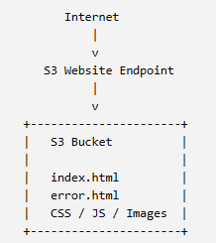
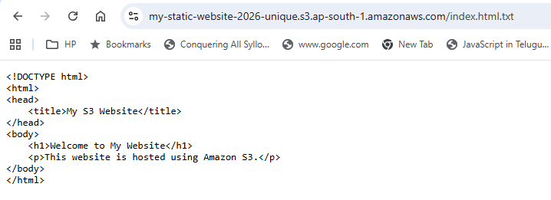

Why use S3 for static websites?
- No server to maintain
- Highly scalable
- Simple deployment
- Low cost
- Suitable for HTML, CSS, JavaScript, images, etc.
3 Create a CDN and attach one SSL certificate.

Objective :
Create a CloudFront CDN distribution and attach an SSL certificate so users can access your application securely over HTTPS.

Prerequisites
  - AWS account
  - An S3 bucket containing your website/files, or an HTTP web server
  - A domain name, for example www.example.com
  - SSL certificate in AWS Certificate Manager (ACM)
  - For CloudFront, the ACM certificate must be created in US East (N. Virginia) — us-east-1

Step 1: Create an SSL Certificate
- Open AWS Console → Certificate Manager (ACM).
- Make sure the region is US East (N. Virginia) us-east-1.
- Click Request.
- Select Request a public certificate.
- Enter your domain:
Stathum.sbs
- Choose DNS validation.
- Click Request.
- Open the certificate and select Create records in Route 53 if your domain uses Route 53.
- Wait until the certificate status becomes:
Issued

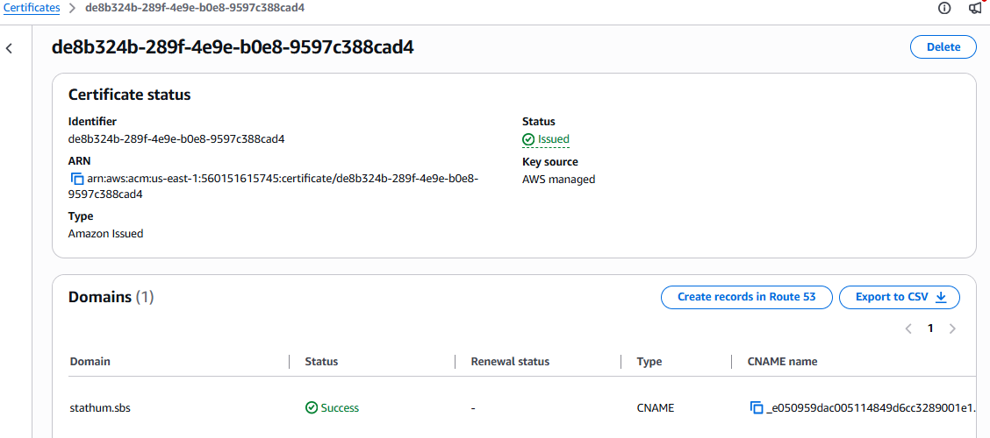

Step 2: Create CloudFront Distribution
- Open AWS Console → CloudFront.
- Click Create distribution.
- Under Origin, select your S3 bucket or enter your web server's origin.
- Configure the default cache behavior:
  - Viewer protocol policy:
Redirect HTTP to HTTPS
  - Allowed methods:
GET, HEAD
- Under Settings, configure:
  - Price class: choose according to your requirement.
  - Default root object:
index.html

Step 3: Attach the SSL Certificate
In the CloudFront distribution settings:
- Find Custom SSL certificate.
- Select the ACM certificate you created earlier.
- CloudFront will use this certificate for HTTPS requests.
- Complete the distribution creation.

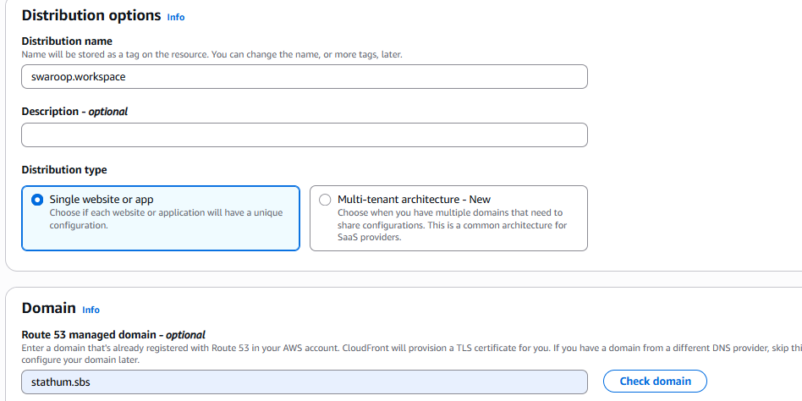
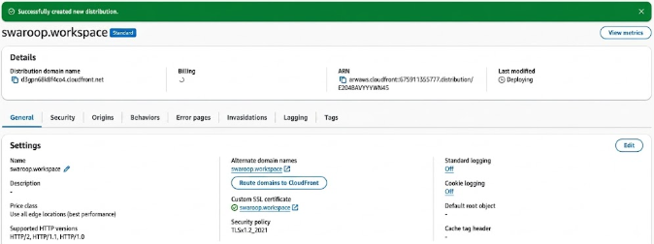
- Create a Route 53 hosted zone and map the domain with the CDN.

Objective
Create an Amazon Route 53 Hosted Zone and map your registered domain to the CloudFront CDN so users can access the application using your custom domain.

Prerequisites
- A registered domain, for example example.com
- CloudFront distribution already created
- CloudFront distribution status should be Enabled/Deployed
- An SSL certificate in ACM (us-east-1)
- The SSL certificate should include your domain
Step 1: Create a Route 53 Hosted Zone
Open AWS Console → Route 53.
Select Hosted zones.
Click Create hosted zone.
Enter your domain:
example.com
Select:
Public hosted zone
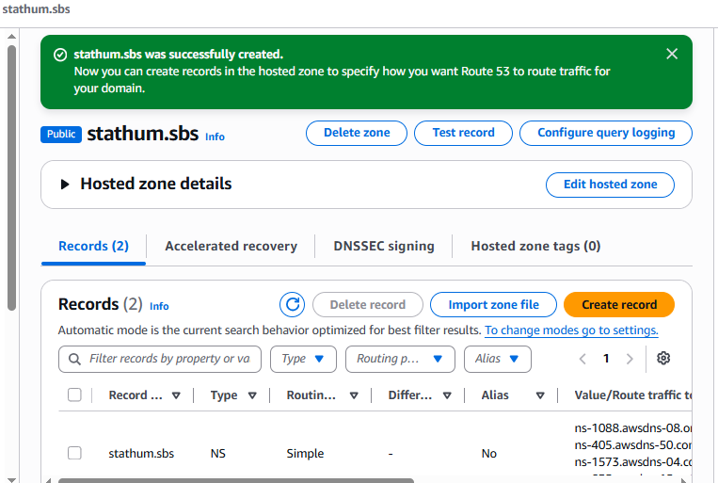

Step 2: Copy the Route 53 Name Servers
Inside the hosted zone, find the NS record.
You will see four name servers similar to:
ns-1088.awsdns-08.org.
ns-405.awsdns-50.com.
ns-1573.awsdns-04.co.uk.
ns-635.awsdns-15.net.

Step 3: Update Nameservers at Your Domain Registrar
If you purchased your domain from Hostinger, log in to Hostinger and open your domain's Nameservers settings.
Replace the existing nameservers with the four Route 53 nameservers.

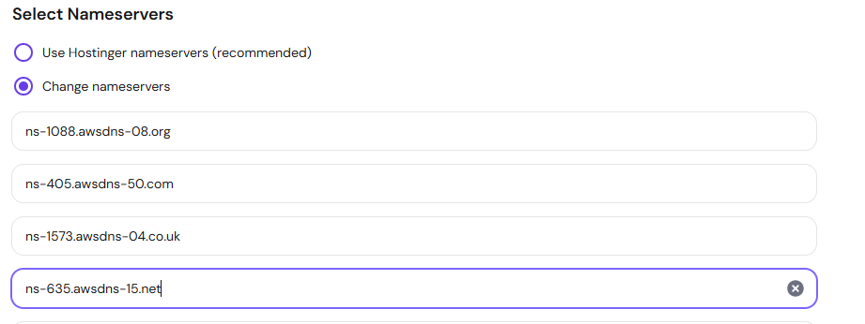

Step 4: Create an Alias Record to CloudFront
Go back to:
Route 53 → Hosted zones → your domain
Click Create record.
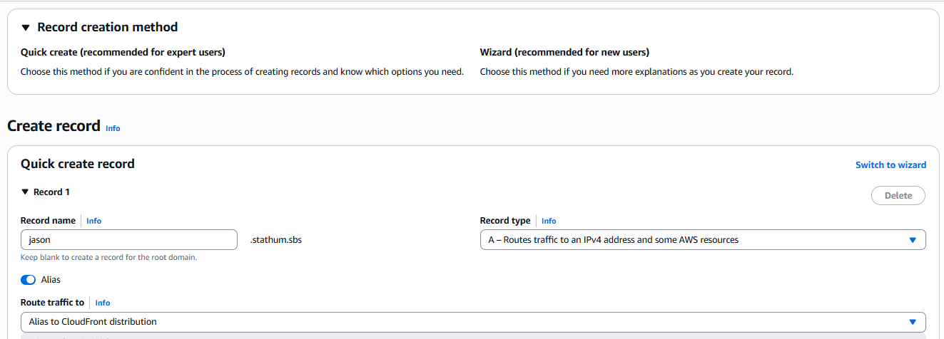

Step 5: Configure the CloudFront Alternate Domain Name
Go to:
CloudFront → Your Distribution → General → Settings

Step 6: Test
Open:
If everything is configured correctly:
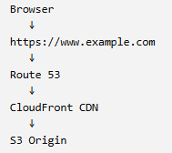

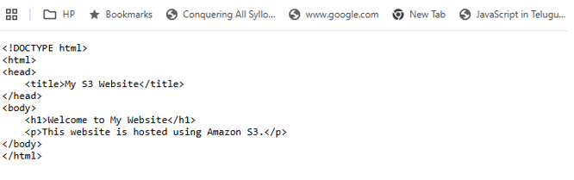
- Update the index.html in the S3 bucket and ensure the updated file is accessible using the domain name.

Objective
Update the website's index.html file stored in an S3 bucket and verify that the updated content is accessible through your custom domain → CloudFront CDN → S3

Prerequisites
- S3 bucket containing index.html
- CloudFront distribution connected to the S3 bucket
- Route 53 domain mapped to CloudFront
- SSL certificate attached to CloudFront

Step 1: Modify index.html
Create or update your local index.html
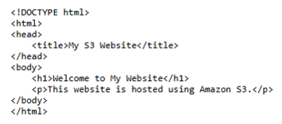

Step 2: Upload the Updated File to S3
Go to:
AWS Console → S3 → Your Bucket → Objects
Select the existing:
index.html
Click Delete if necessary, then click Upload and select your updated index.html.
Or, using AWS CLI:
aws s3 cp index.html s3:// devops-source-bucket-unique-name/index.html

Step 3: Check the CloudFront Distribution
Go to:
AWS Console → CloudFront → Your Distribution
Confirm:
Status: Enabled
Last modified: ...

Step 4: Create a CloudFront Invalidation
Go to:
CloudFront → Distribution → Invalidations → Create invalidation
Enter:
/index.html
/*
Click Create invalidation.
Wait until the invalidation status becomes:
Completed

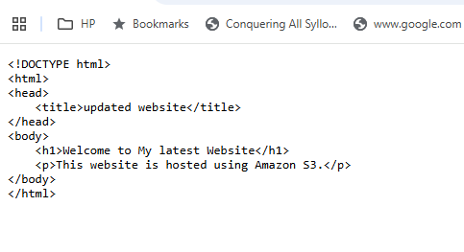
Architecture :
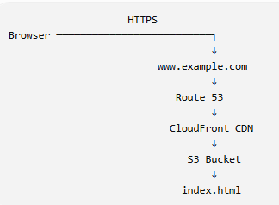
7.Share the domain name in Slack to test the connectivity.

Static website deployment completed.
URL: https://swaroop.workspace /
Please verify the website connectivity

